Erasmus+ Student Traineeship
LANGUAGE ASSISTANT
Universidad de Cádiz (UCA)

With the aim of promoting European internationalization and offering students the possibility of personal and professional development, this offer of a practical training stay at the University of Cadiz is launched, in accordance with the lines of action of its strategic plan for internationalization.
The University of Cadiz is a public university located in the province of Cadiz, Andalusia, in southern Spain. Although officially established in 1979, the university can trace its origins back to the 15th century. UCA has four campuses located in four different cities of the province: Cadiz, Puerto Real, Jerez and Algeciras.
The province of Cadiz has a rich history which has left behind a remarkable imprint reflected in its streets, which you can explore while enjoying the wonderful climate.
The UCA is the coordinator of SEA-EU, the European University of the Seas - an alliance of 6 Universities (Cadiz, Brest, Kiel, Gdańsk, Split, Malta) to establish a distinctly international, pluri-ethnic, multilingual and interdisciplinary European University. This vision is rooted in the high quality and excellence in education and research of the alliance with the intent to strengthen the links between teaching, research, innovation and knowledge transfer.
The University of Cadiz has developed a meticulous plan of precautionary measures with regard to the COVID 19 situation, and teaching is currently taking place in a controlled classroom environment.
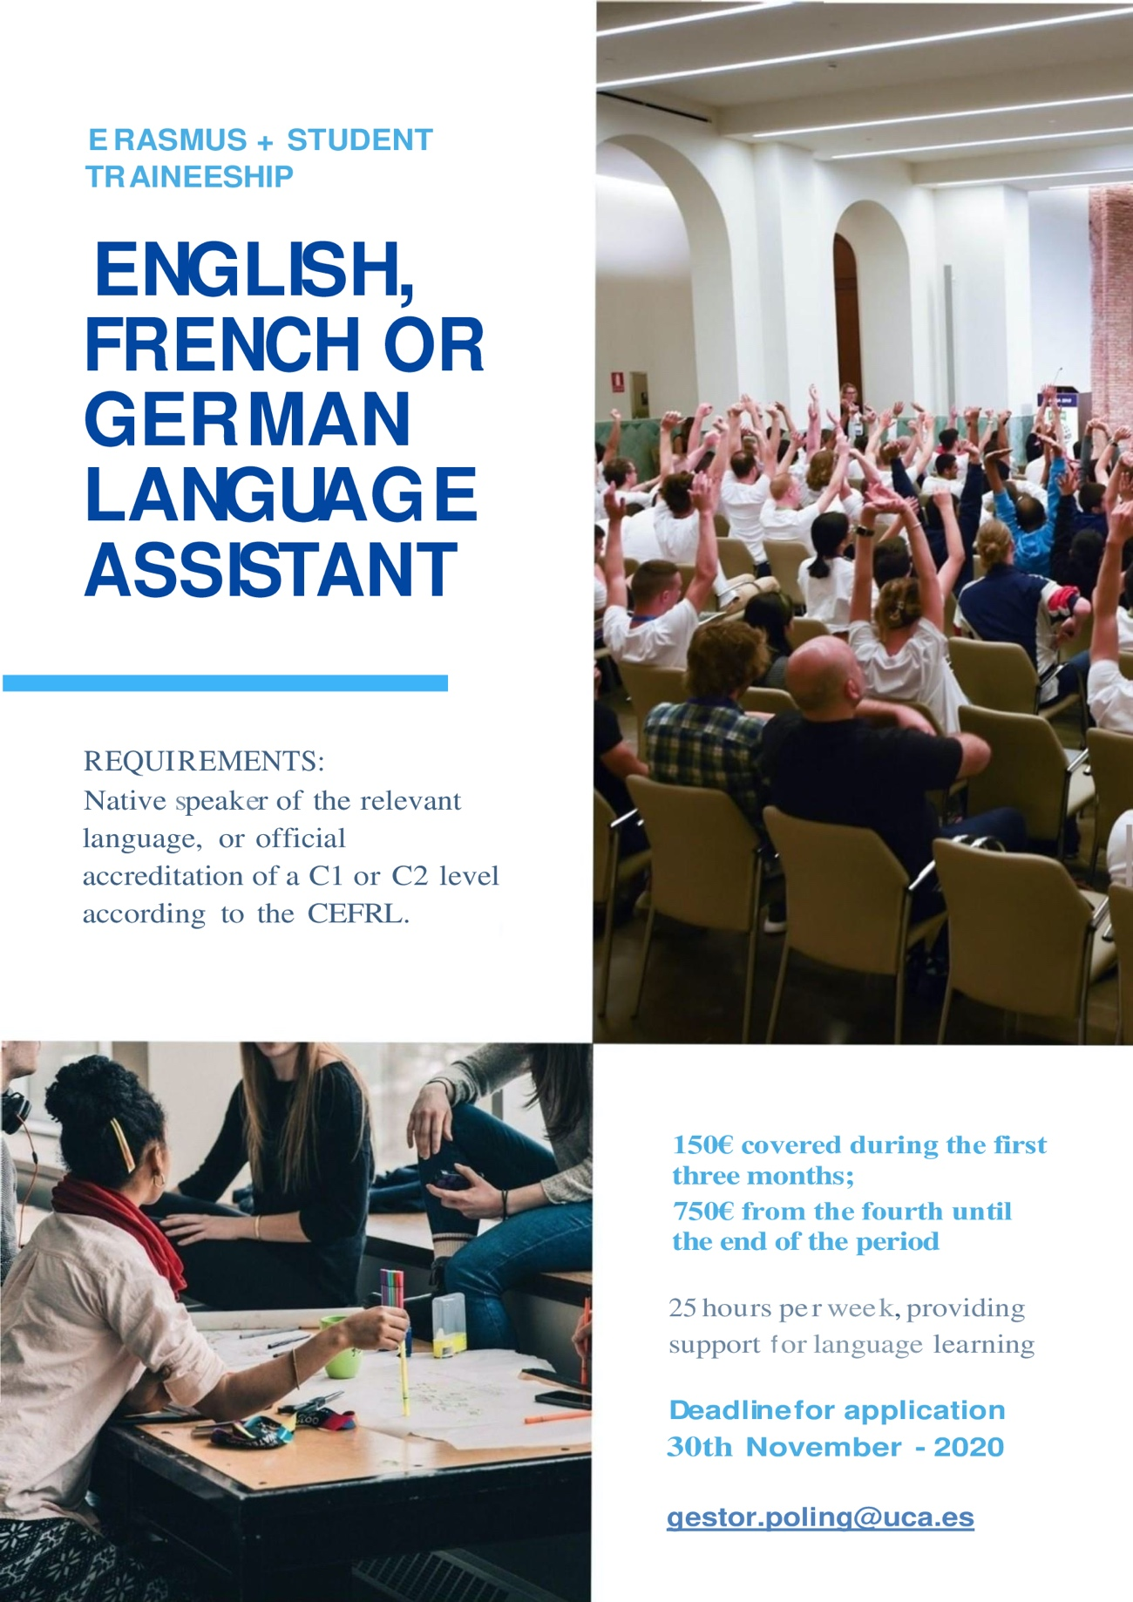

PLACEMENT INFORMATION
ROLE | Language Assistant for a) English b) French or c) German
DESCRIPTION OF ACTIVITIES | You will provide support for language learning through activities such as practical conversation classes including sociocultural aspects of the language in question. You will also support students and university staff through weekly tutorial sessions and attend coordination meetings with related staff. Occasional collaborations in institutional activities where the presence of a native speaker would be beneficial may be requested. You will receive training to help you develop your role.
START DATE | FEBRUARY 2021
END DATE | JUNE 2021
WORKING HOURS PER WEEK | 25 hrs
ACCOMMODATION | http://alojamientouca.com/
STUDENT BENEFITS | As a participant in an Erasmus+ exchange, you can enjoy the benefits and services available to all our international students.
FINANCIAL ASPECTS | 150€ covered during the first three months; 750€ from the fourth until the end of the period.
REQUIREMENTS
LANGUAGE LEVEL | Native speaker of the relevant language, or official accreditation of a C1 or C2 level according to the CEFRL.
HOW TO APPLY
CONTACT | gestor.poling@uca.es
PROCESS | Please complete the form below and send it along with your CV, your language accreditation and a letter of motivation to the above email address.
DEADLINE | 30th November 2020

FORM
Name
Surname
Nationality
Date of Birth
Email address
Phone Number

University

Degree programme |  | Current year of study

I am applying to be a language assistant for: | English | French | German
Other languages you are fluent in

By sending this form you are accepting that your personal data will be managed by the University of Cádiz.
The University of Cádiz will process your personal data in accordance with the provisions of Regulation (EU) 2016/679 of the European Parliament and of the Council, of April 27, 2016, regarding the protection of natural persons with regard to data processing personal data and the free circulation of these data and by which Directive 95/46 / EC (General Data Protection Regulation) and other applicable regulations are repealed.

